24-Hour Clock Alarm
Nicholas Christensen
Colorado State University Global
CSC500: Principles of Programming
Prof. Steven Evans
5/31/2026
24-Hour Clock Alarm
This program calculates the time an alarm will go off using a 24-hour clock, where 0 represents midnight and 23 represents 11 p.m. It prompts the user for the current time in hours and the number of hours to wait, then uses the modulo operator to wrap the result around a 24-hour cycle. It is written in Python (version 3.13) and was developed in Visual Studio Code.
Pseudocode
The logic of the program in plain English:
START
DISPLAY "24-Hour Clock Alarm"
PROMPT user for the current time in hours (0-23) and store in currentTime
PROMPT user for the number of hours to wait and store in waitHours
IF either input is not a whole number in the valid range THEN
DISPLAY an error message and ask for that value again
END IF
COMPUTE alarmTime = (currentTime + waitHours) MOD 24
DISPLAY currentTime, waitHours, and alarmTime
END
Source Code
The complete source code is saved as alarm_clock.py and is also submitted alongside this document.
# 24-Hour Clock Alarm
# Asks the user for the current time and how many hours to wait,
# then uses the modulo operator to find the time the alarm will go
# off on a 24-hour clock (0 = midnight, 23 = 11 p.m.).

def get_int(prompt, minimum, maximum):
while True:
try:
value = int(input(prompt))
except ValueError:
print("Invalid input. Please enter a whole number.")
continue
if minimum <= value <= maximum:
return value
print(f"Please enter a whole number between {minimum} and {maximum}.")

def main():
print("24-Hour Clock Alarm")
print("-------------------")

current_time = get_int("Enter the current time in hours (0-23): ", 0, 23)
wait_hours = get_int("Enter the number of hours to wait: ", 0, 1000)

alarm_time = (current_time + wait_hours) % 24

print("\nResults:")
print(f"Current time: {current_time}:00")
print(f"Hours to wait: {wait_hours}")
print(f"Alarm goes off: {alarm_time}:00")

if __name__ == "__main__":
main()
Screenshots
Figure 1
Source code in Visual Studio Code.
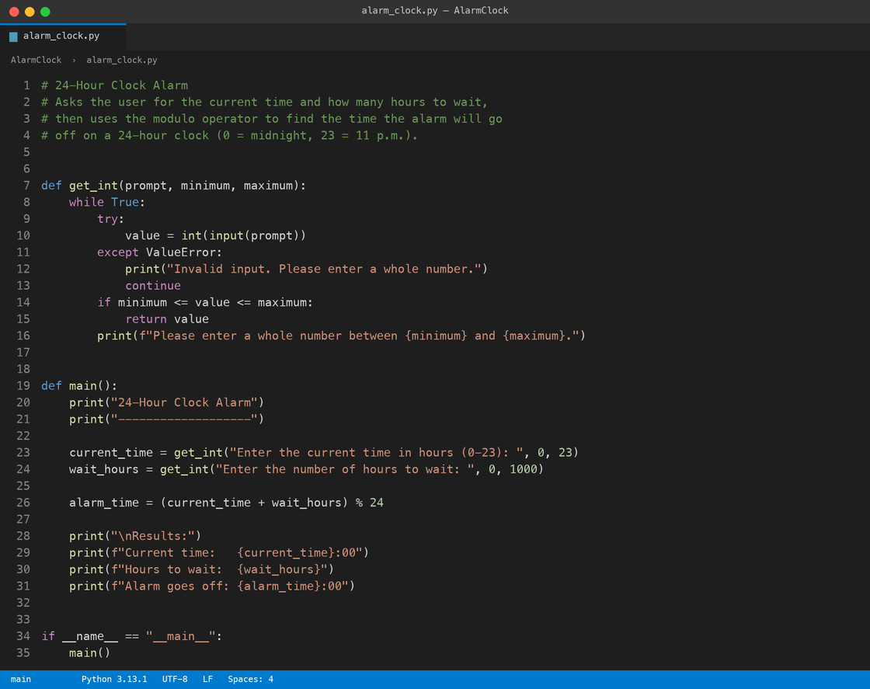
Figure 2
Program output in the terminal.
